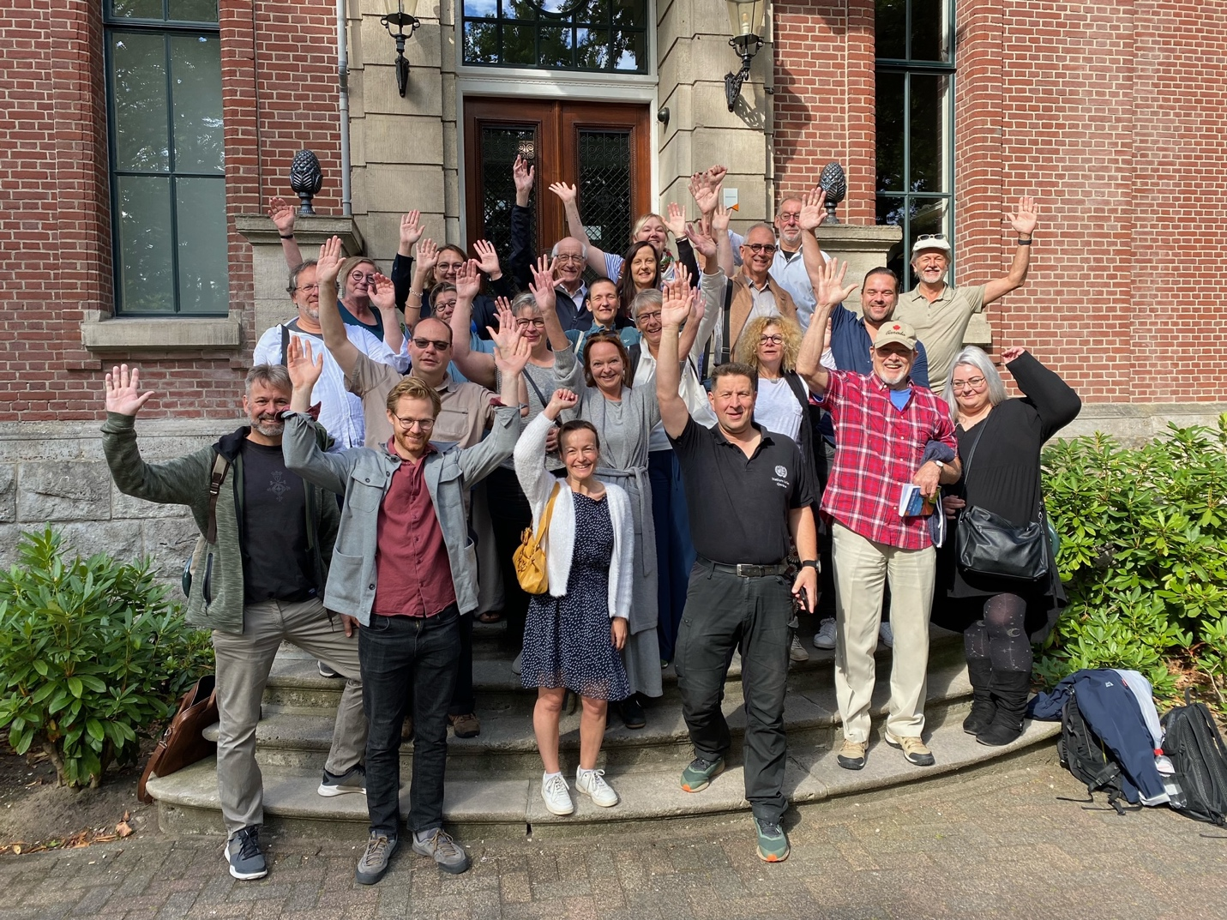A Canadian Humanist Chaplain

Meets Like-Minded Professionals in Europe

by Dr. Marty Shoemaker, AHC

July 25-29, 2022, a stimulating event occurred in the Netherlands. No, it wasn't a soccer match, a bike ride to The Hague, or a boat ride on one of the canals that make Holland unique. Interestingly, close to 30 Humanist professionals came together just outside Amsterdam for a Summer School. This form of learning is quite popular with those professionals associated with the University of Humanistic Studies located on the Utrecht’s main campus.

So how did one of our Humanist Canada’s accredited chaplains find their way to this distant school? I must confess, about a decade ago, when learning about this university for humanist professional training, the first in the world, founded in 1989, I was instantly envious and wanted to attend or at least learn how they got started and secured government funded. UVH (Universiteit Voor Humanistiek) was founded to recognize the worldview of Humanism as a legitimate philosophy of life that deserved its own center to educate and send graduates across Europe. As the first nation to start a Humanist Association in Europe after the Second World War in 1948, the Netherlands has set a high bar for us to follow in Canada.

Reading about this summer school, I was compelled to attend. When I entered my application, the organizers, the European Humanist Professionals (EHP) and, particularly, Gerjos Hengelaar, a Dutch military chaplain, were most inviting. They reached out to both David Savage, the founder of the Non-religious Pastoral Care Network in England and myself to lead a seminar about our local chaplaincy programs. Although we are the new kids on the block, these European chaplains and Humanist leaders are keenly interested in our successes and the challenges ahead. These Humanist colleagues are definitely among the “like-minded” and incredibly engaged with the expansion of global Humanism and how to connect, share and assist.

HUMANIST CHAPLAINCY IN EUROPE VS NORTH AMERICA

Chaplaincy is a 1600 years old profession in Europe if you are Catholic and 600 years old as a Protestant. For Humanists, chaplaincy started to develop in the 1950s, first in Belgium and then in the Netherlands. Both countries now have government and community-funded Humanist professionals and institutions. Yes, you read that correctly, government-funded. Belgium has between 25%-40% of their population of 11.6 million identified as non-believers but not necessarily Humanists. Belgium has over 480 registered Dutch and French-speaking Humanist chaplains and professionals, most paid by agencies. The Dutch Humanist Society reports 240 working and paid chaplains.

Many of these Chaplains are equal in status to the older, more traditional religions that still have the majority. Still, they all serve together in universities, prisons, military assignments and health facilities. Secular professionals in Belgium, Netherlands and Norway often have a well-respected niche working as both chaplains and counsellors. Norway has the highest membership numbers, over 100,000 or 2% of their 5.5 million residents but has fewer chaplains. Italy, Ireland, and Iceland sent interested participants but are not yet approved or funded. England has made significant strides with their Non-Religious Pastoral Care Network in the NHS, but most are still volunteers. Recently, they have developed university-based training.

In comparison, here in North America, Humanist Canada has six chaplains, four in universities, one historic-first accredited chaplain in our Canadian Armed Forces and one assigned to our membership of around 750 as of July 2022. Canadian Humanism started in our large cities, Montreal, Victoria, Vancouver and Toronto, during the 1950s and came together as a National organization in 1968. Our first volunteer chaplains started at the University of Toronto in 2009-2010, and our accreditation program in 2021. Ontario-based Officiants and their ceremonies have been recognized since 1997. Other provinces have not approved Humanist officiants yet but pushing for certification is on our radar.

Our neighbours to the South, American Humanist Association, started in 1941, but its training and certifying of Chaplains and Officiants began in the early 2000s by their Humanist Society. They report over 200 certified professionals, with the majority of chaplains being unpaid volunteers unless they are hired to work in a hospital or prison following a Master's in Divinity and Clinical Pastoral Education. It is a long road for Humanist applicants. The secular curriculum at the University of Utrecht in philosophy, social science, counselling, Humanist values and ethics, and general religious literacy is so attractive and relevant.

HUMANIST CHAPLAINCY GOING FORWARD

These are indeed exciting times as Humanist Canada has joined thousands of European, Asian and American professionals who relish their role as ambassadors for reasoned solutions, compassion-based service and an evidenced toolkit to serve humanity whenever possible. We have not been a recognized voice in the power structures in our governmental institutions until of late. We are also working on equivalent educational programs to replace Divinity degrees and developing a new narrative to replace only supernatural spirituality and religious rituals and drive a number of pressing social justice and political initiatives.

As Canadian chaplains, we must be prepared to answer new questions, "Why are you here?", "Why should I refer to you?" and "What is a Humanist chaplain?" Summer Schools, like the one I attended in Europe, have addressed and shared their responses with learned experience and acumen we here in Canada can leverage with confidence and enhance our chaplaincy career option with renewed vigour and confidence.

WE HAVE JUST STARTED.